Supervision 3 Answers

Price discrimination refers to a pricing strategy where a firm varies its price across units and customers, in order to convert some consumer surplus into producer surplus. These pricing strategies require firms to have market power, and the ability to prevent consumers ‘faking’ their willingness to pay, and thus be subject to a lower price. Further, the firm needs a mechanism to prevent market seepage, which occurs when consumers subject to this lower price resell the product to a consumer with a higher willingness to pay. There are three types of discrimination: first, second and third degree.
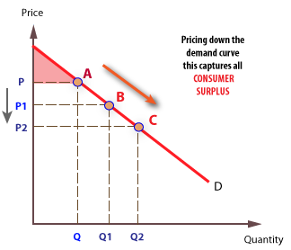
With first degree price discrimination, the firm sells each unit of output to the individual with the highest willingness to pay, meaning each unit of output is sold at a different price. This eliminates all consumer surplus, the difference between a consumer’s willingness to pay and the equilibrium price, instead converting it into producer surplus, or profits. Interestingly, as a result, there is no deadweight welfare loss here, but the situation is still thought to be highly undesirable from a societal perspective. To engage in so called ‘perfect’ price discrimination, firms not only need market power, but also perfect information regarding the tastes of each consumer. The transaction costs involved in using market research to obtain each individual’s willingness to pay has traditionally deterred this practice, however in the digital age perfect price discrimination is becoming increasingly plausible, as firms can use cookies, geolocations, mouse trackers and other software to more cheaply and quickly form and idea of a consumer’s willingness to pay.
An example of first-degree price discrimination could be client-facing service providers, such as business consultancies or commercial law firms. Here, the firm may be able to charge a fee based on the value added to each specific client (willingness to pay) and the size or value of the firm (ability to pay). For example, referring to Figure 1, our consultancy firm might charge a large client like Sony price P, but charge a smaller client price P2 for the same service. These differential prices could be enforced because of asymmetric information, whereby the service provider has access to detailed financial reports of their client and the nature of the problem they face, therefore has a clear idea of the firm’s ability and willingness to pay. Further, in a sense the client may be ‘locked in’ to working with a specific consultancy or legal firm, because of ongoing cases or because of the understanding the service provider has of its culture and strategic goals.

Second-degree price discrimination can be employed to achieve a similar effect where the firm is unaware of each individual consumer’s willingness to pay. The firm need only know that there is variability in their customers willingness to pay, which they can capitalise upon by inducing consumers with a high willingness to pay to self-select into this pricing option. This is done by varying prices across the quantity and quality of units bought, such as discounts for bulk purchases, intertemporal pricing strategies, and using product differentiation.
A good example of second-degree pricing discrimination is the airline industry, in which consumers face intertemporal pricing and versioning. Consumers purchasing a plane ticket nearer to the flight date tend to face a higher price, because the firm knows such consumers have a higher willingness to pay, as they will have more limited options to reach their destination. It is worth noting, however, that firms may occasionally discount seats closer to the flight date if they have excess capacity. This is viable because of the huge fixed costs of the flight, and low marginal costs of an extra plane seat. Simultaneously, by offering a variety of product versions, such as economy, business and first class, firms can induce consumers to self-select into the pricing scheme most accurately suits their needs, thus converting some of their consumer surplus into producer surplus.

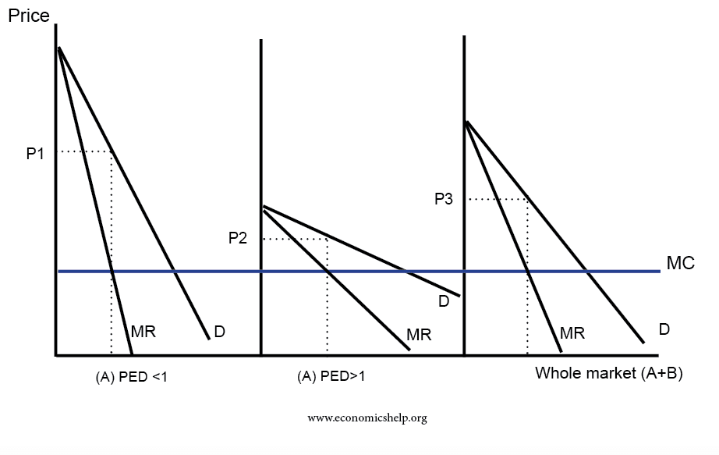
Third degree price discrimination, also known as multi-market price discrimination, involves segmenting the consumer base into broad groups based on their differing price elasticities of demand and willingness to pay. At its most simple level, the firm will categorise its consumers into two groups, one with a more price inelastic demand and one with a more price elastic demand, and then charge a higher price to the first group and a lower price to the latter. This is beneficial to the firm as the units sold to the first group generate a higher level of producer surplus, extracting some of the consumer surplus that this group would have achieved at the equilibrium price. Further, by charging a lower price for price sensitive consumers, the firm can increase its profits by expanding its consumer base to those who may not have been willing to pay for the product at the equilibrium price. This assumes that the lower price still exceeds marginal costs. An example of third-degree price discrimination can be seen in the public transport sector, where many bus and rail services vary their prices based on whether the consumer falls into one of three categories: student, adult, or pensioner. Here, it is relatively easy for firms to enforce differential prices and prevent market seepage, as they can require identification to verify which group the consumer is in, both at the point of purchase and at the point of use. Further, this example works because the observable characteristic, consumer age, is a somewhat accurate indicator of a consumer’s willingness to pay. For example, offering different prices based on consumer hair colour, whilst equally observable and enforceable, would be less effective as this characteristic does not indicate a consumer’s willingness to pay.
Figure 3 shows how the different elasticities of demand of different consumer segments lead to different prices per segment, if the firm can separate its consumer base and enforce this separation. Using the rail travel example, adults would pay P1, and students and pensioners would pay P2. It is worth noting that second and third-degree price discrimination are increasingly viable where marginal costs are low and do not rise steeply with output. This is because a flat marginal cost curve increases the profit-making range of prices the firm can offer to consumers with a lower willingness to pay.

There are several theories concerning the reasons why firms exist, and what determines their size. One way of categorising them is into neoclassical, managerialist, behaviourist and transactions costs.
The neoclassical view of the firm is that shareholders, the owners of a firm, seek to maximise the income they receive from dividends. Given that dividends are paid out of firm’s profits, the objective of the firm is therefore to maximise profits, thus the income of the shareholders. This is the purpose of the firm in the neoclassical view. From this premise stems the criteria which determines the firm’s size and scope. Neoclassical theory dictates that firms should produce at the profit-maximising level of output which is where marginal costs are equal to marginal revenue. As marginal cost is upward sloping, and marginal revenue downward sloping, any output level below where MC = MR would fail to capitalise on additional units for which MR > MC i.e., profitable units. The opposite would apply if the output level were beyond this point. Assuming firms have access to perfect information regarding these revenue and cost curves, this criterion shows clearly what a firm’s size should be.
Whilst asserting the same reason for the existence of the firm – to maximise the income of owners – the managerialist view (Williamson) is that the principle-agent problem (Ross, 1973), stemming from the divorce of ownership and control in modern firms, prevents this goal being pursued or achieved. The idea is that although shareholders may wish to see profits maximised, it is the manager who is in control of the day-to-day running of the firm. Although managers can be held accountable by owners, such as at AGMs, these occur infrequently. Therefore, there is asymmetry of information regarding managers’ activities, which they exploit to pursue their own objectives, aside from shareholders’. According to Williamson (1964), managers achieve a satisfactory level of profit before seeking to maximise their own utility, based on their salary, job security, dominance, and professional excellence. Applying the managerialist theory, the size and scope of the firm is determined by the manager’s pursuit of these drivers of utility, including “pet projects” necessitating product differentiation.
Linking to this, the behaviourist view of the firm explores how psychological biases and bounded rationality affect the size and scope of the firm. Rooted in Simon’s bounded rationality theory, the behaviourist view is that firms engage in satisficing behaviour, as opposed to optimising, with respect to several goals including profits, market share and sales (Cyert; March). This view is supported by the fact that in large firms, decisions are taken by multiple stakeholders with conflicting aims and therefore instead of maximising one at the expense of the other, the firm satisfices all aims. In addition, consumer-focused behavioural considerations such as the preference consumers have for price stability can prevent a firm from short-term profit maximisation. Behaviourist theories hint that manager’s goals for the size and scope of the firm can be determined by rival’s performance and by the firm’s own performance relative to past targets. Further, as managers are slow to adjust targets to market changes, organisational slack can develop, whereby if the firm overachieves, targets remain the same and “slack” develops, which is taken up if the firm then underperforms.
Finally, the transactions cost view of the firm provides another reason for the existence of firms; firms can organise production and distribution in a manner incurring lower transaction costs than the free market. Coase emphasised the “Problem of Social Cost”, the costs of contracting using the price mechanism, including search, bargaining, and enforcing costs. According to this theory, the size and scope of firms is determined by the cost of internalising a process in a firm, relative to the transaction costs saved as opposed to using the market. After a certain point, as the firm branches beyond its core specialities, the cost of internalising a process through training or vertical integration rises with scale. Therefore, the firm exists at the size and scope at which transaction costs are equalised.
- Easier to charge differential price for service than good
- Dumping third degree price discrimination – selling at a lower price for domestic purpose and higher price internationally?
- Third degree price discrim could involve charging higher prices to early adopters

- Neoclassical, entrepreneur is owner, profit maximising, each time period is independent (decisions in one don’t influence subsequent), profit max at MC = MR. Perfect knowledge.
  - Input prices, competitors, demand functions, economies of scale
  - Bounded rationality: cost of acquiring information and also distortion of information as it moves through hierarchical levels. Imperfect knowledge of cost and demand curves
  - Temporal nature of decisions, path dependency
- Marris’ model of managerial enterprise, Baumol sales maximisation and Williamson model of managerial discretion.
  - Baumol – managers pursue sales maximisation because there is a correlation between sales and salary, sales and the firm’s prestige, and the manager’s prestige and manager’s are risk avoiders; they don’t want large profits followed by small profits. Sales revenue maximisation subject to a minimum level of profit constraint
  - XpieM is where profit maximising firm will operate. In Baumol, firm will achieve the sales revenue maximised (when TR is maximised) so firm will produce at XSM
- Marris model: maximisation of a balanced rate of growth, so firm aims for demand growth (sales growth). Manager aims to satisfy his own utility (demand growth) and the growth of supply of capital (shareholder’s goal). Manager and shareholder have different utility functions.
  - Marris comes to a middle part, manager jointly maximises both utility functions
- Williamson model of discretion. Manager maximises his own utility which is a function of salary, job security, power and professional excellence.
  - Maximises funds available for discretionary investment
  - Maximises slack payments (emolurent payments to himself) e.g. big office
  - Equilibrium of firm is point of tangency between profit curve and the highest possible manager’s indifference curve
  - Manager maximises his own utility, not profits. Higher output, lower prices and less profits than a maximising firm
- Transactions cost theory.

- Chandler. Pre-1850 dominance of small, family-ran businesses with no dichotomy between owners and managers. Price determined by equilibrium.

- Post 1850 managerial enterprise (allocating productive resources) and coordination was what driven growth, lower costs higher productivity and profits.
  - Separation of management and ownership
- Managerial organisation and structure determined competitive advantage.
- Overemphasises the roll of managerial enterprise?
- Supporters say tech advances
- Chandler relevant companies still investing in their capabiliites to build markets e.g. Microsoft. Still big advantages to vertical integration and managers need incentives to achieve these EoS

